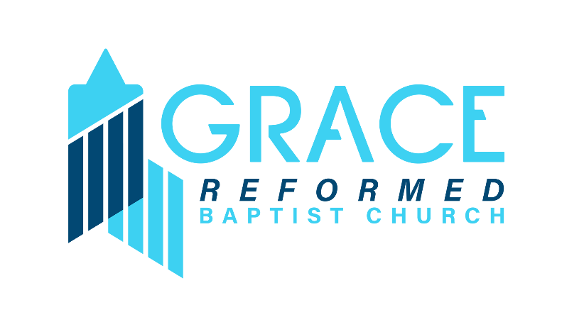

36 Smith St, Merrick,

NY 11566

# Vacation Bible School Permissions and Releases

This form must be completed by a Parent or Guardian of the minor(s) participating in Vacation Bible School.

**Name of Parent or Guardian completing this form (please print):**

________________________________________

**Names of minors participating in VBS to whom these permissions and releases apply:**

__________________________________________________________________________________________

**1. PERMISSION TO PARTICIPATE**: I am the parent or guardian of the **above listed minor(s)** and I give permission for him/her/them to participate in Vacation Bible School (VBS) activities and be under the care and supervision of employees and volunteers at the Grace Reformed Baptist Church from July 29th through August 2nd, 2024.

**2. LIABILITY RELEASE**: In consideration of Grace Reformed Baptist Church allowing the above minor(s) to participate in VBS, I do hereby release, forever discharge and agree to hold harmless Grace Reformed Baptist Church, its directors, employees, volunteers and agents (collectively herein the “Church”) from any and all liability, claims or demands for accidental personal injury, sickness or death, as well as property damage and expenses, of any nature whatsoever which may be incurred by the undersigned and the above minor(s) while involved in VBS.

**3. MEDIA RELEASE: I** give permission to Grace Reformed Baptist Church to photograph, videotape my minor(s) for purposes of in-house church use and/or for public information or promotion of the church (i.e., brochures, website, future VBS), and/or for social media posting. I also understand that no royalty, fee or other compensation shall become payable to me by reason of use. **No** such use of these images or recordings will identify the name or other personal information of the minor(s).

**I have read and understand all three (3) of the above stated permissions and releases and agree that by signing below I am accepting the terms, granting the permissions, and agreeing to the releases as stated therein.**

_________________________________________________________

Parent/Guardian’s signature Date:

Church office: (516) 379-2408 Event email: GRBC.LI.VBS@GMAIL.COM