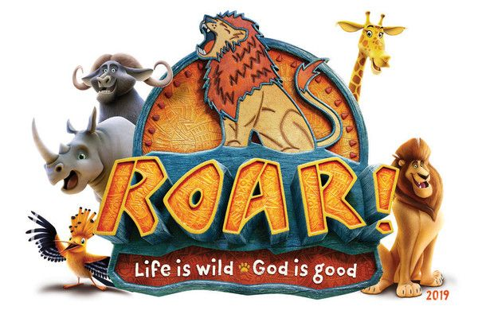

RELEASE FOR PUBLICATION
Vacation Bible School 2019
Allentown Presbyterian Church
20 High St., Allentown, NJ 08501

Please check ONE:

______ I, the undersigned, hereby grant permission to the Allentown Presbyterian Church to take and publish photographs, videotapes, voice recordings, or any other likenesses of my child for use in published material (includes print, web based, or other media types) that may be presented in the public domain (outside of Church services or Church-sponsored programs, ministries, activities, or events) for the purpose of promoting Church-sponsored programs, ministries, activities or events.

______ I, the undersigned, do NOT give permission as outlined above.

_____________________________________________________________
Please print child(ren)’s name(s)

_______________________________________________ ______________
Parent’s/Guardian’s signature Date

