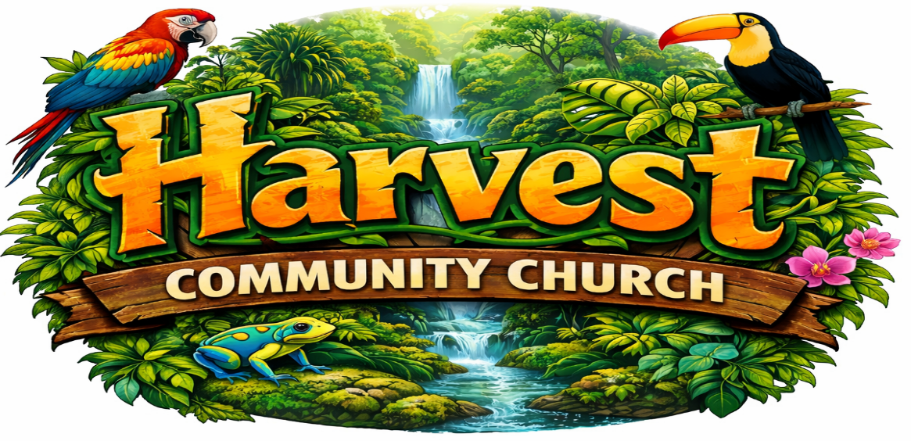

Vacation Bible School 2026 Liability Release and Photo Consent

LIABILITY RELEASE
I, _____________________________________________, being the parent/legal guardian of _________________________________________, hereby release Harvest Community Church (HCC), its agents, employees, its assigns, and volunteer assistants from any liability arising out of injury, sickness, or damage which may be sustained by my child during the course of his/her attendance during Vacation Bible School occurring June 22-26, 2026. I hereby certify that I have read and agree to the above liability statement.

Parent/Legal Guardian Signature: Date:

PHOTO CONSENT
I also recognize that the church uses photographs and video images of its participants and volunteers each day during Vacation Bible School. These images are shown to the children during our closing session. We may also print pictures to hang in classrooms, church hallway, or use the pictures on our church’s website. We do not print names or other personal information with photos. I hereby grant permission for photo/video images of my child to be taken and used for such purposes.

Parent/Legal Guardian Signature: Date:

