Ordered ______ Paid ______ Awarded ______

 Clubber’s Name __________________________________________

2018-2019 Order form

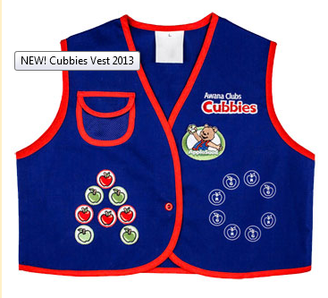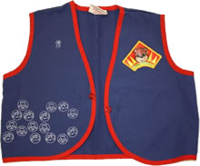

Uniform Vest………………………$11.00

Small, size 4 _______

Medium, size 5 _____

Large, size 6 _____

X-large, size 8 _____

XX-large, size 10 _____



Honey Comb Handbook…..….$10.00 ________



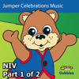 Honey Comb Handbook Music CD…… $8.00 ________

Total _____________

*Please make out all checks to Faith Discovery Church*