 Ordered ______ Paid ______ Awarded ______

Clubber’s Name _____________________________________

2018-2019 Order Form

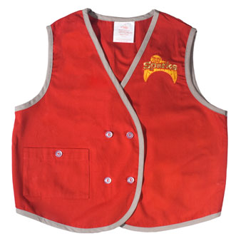

Uniform Vest………………………$11.00

Small, size 6 _____

Medium, size 8 _____

Large, size 10 _____

X-Large, size 12 _____



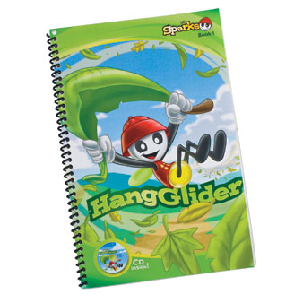

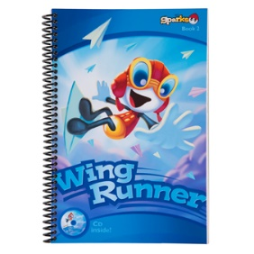 Sparks Handbook………………. $11.00

Hang Glider (yr. 1) _____

Wing Runner (yr. 2) _____

Sky Stormer (yr. 3) _____

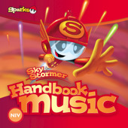 Sparks Music CDs………………. $10.00

Hang Glider (yr. 1) _____

Wing Runner (yr. 2) _____

Sky Stormer (yr. 3) _____

Awana music also available on iTunes

Total _____________

*Please make out all checks to Faith Discovery Church*