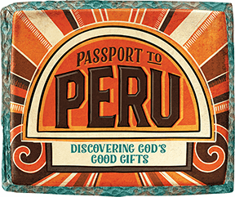

Dear Parents, Grandparents, Friends and Neighbours,
Immerse kids in Global Culture. Kids are invited to experience the sights, sounds, smells, and tastes of a unique culture at VBS, where kids discover how much God loves the world. It’s like taking a trip to Peru! Kids will participate in Bible-learning adventures, cultural experiences, team-building games, unique treats, make awesome crafts, and sing cool faith-building songs.
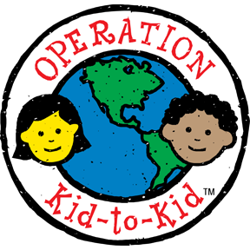
As part of learning about what children experience in Peru, we will be raising funds to provide fresh, clean water for children in Peru. (See document entitled “Operation Kid-to-Kid”). There is no cost for VBS. This is a freewill offering only.

You are all invited to our VBS closing program – Friday, July 14th at 11: 30 am, followed by a light lunch.
Join us for our Vacation Bible School Worship Service on July 16th at 10:30 am. All VBS participants will be joining in to lead the singing.

If you have any questions or concerns, please do not hesitate to call or e-mail:
Director Kristi Anger: 905-348-1427 kristianger@gmail.com
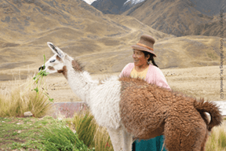
The Church: 905-835-2361

