


Things you should know:
- The registration/check-in table will be inside Door B, the Sanctuary entrance. Door “B” will be the only door unlocked through the VBS night.
- If you are interested in the music, you can find it on You Tube or to purchase at group.com/vbs.
- Registrations are encouraged before the first night but are welcome anytime. Come one night or come all five.

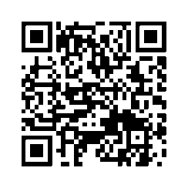
Registration Notes:
- Children should register based on their last completed grade.
- All children MUST be potty-trained.
- Any child that registers will be able to attend, there is no limit.

What happens at VBS?
We start with everyone together- singing, a skit, and a preview of the night. Then all of the children rotate between the following areas; bible lesson, crafts, snacks, games, and music. We finish the night in the sanctuary with singing & a daily overview. The whole evening is focused around a theme and is reinforced in every area traveled to.


Our Savior Lutheran worship opportunities:
Sept. - May Memorial Day- Labor Day
Saturday 5:00 p.m. Saturday 5:00 p.m.
Sunday 8:00 & 10:45 a.m. Sunday 8:00 & 10:00 a.m.
Sunday School 9:30-10:30 a.m. No Sunday School

