VBS Daily Details
Monday
Bible Point: God made you.
Bible Story: God lovingly creates people.
Psalm 139, Genesis 1:26-2:4
Color: Blue
Snack: Maker Mix
Tuesday
Bible Point: God is for you.
Bible Story: Rahab believes in God’s mighty power.
Joshua 1-2
Color: Green
Snack: Marshmallow Forts
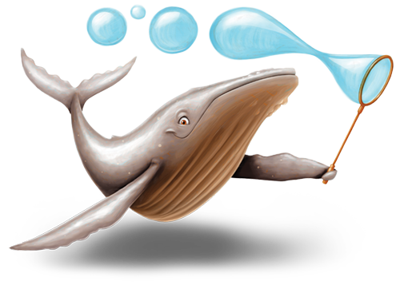
Wednesday
Bible Point: God is always with you.
Bible Story: God is with Gideon.
Judges 6:11-7:25
Color: Orange
Snack: Mozza-Roll-Up
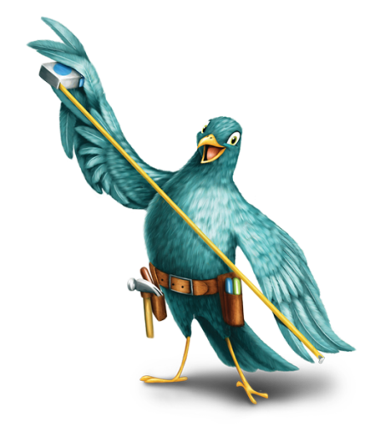
Thursday
Bible Point: God will always love you.
Bible Story: Jesus dies and come back to life.
Luke 22:66-24:12
Color: Red
Snack: S’more of God’s Love

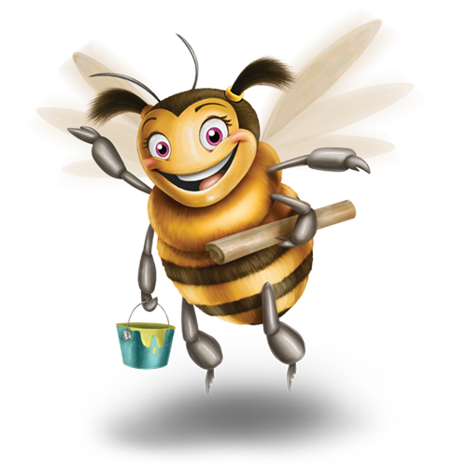
Friday
Bible Point: God made you for a reason.
Bible Story: Abigail brings peace.
1 Samuel 25
Color: Yellow
Snack: Nacho Plan
*Ice Cream Social at 4:00

Sunday
Color: Wear your VBS t-shirts!
Snack: Donuts in Fellowship Hall

