
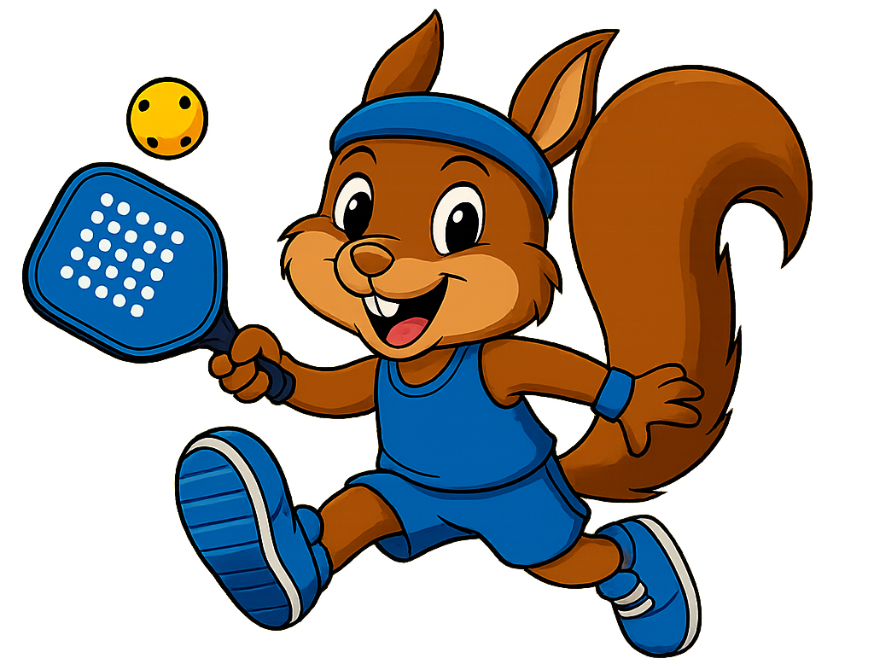
Daily Details
Don't let anyone put you down because you're young. Teach believers with your life: by word, by demeanor, by love, by faith, by integrity.
1 Timothy 4:12 (The Message)

Monday: Young Believer
Bible Story: 1 Timothy 4:6-16
Color of the Day: Blue
Snack: Skinny Pop Popcorn
Baby Moses (and Big Sister Miriam): Tuesday
Bible Story: Exodus 2:1-10
Color of the Day: Purple
Snack: Snyder’s Pretzels
Wednesday: The Healing of Naamen
Bible Story: 2 Kings 5:1-19
Color of the Day: Green
Snack: Veggie Straws
God Calls Samuel: Thursday
Bible Story: 1 Samuel 3:1-20
Color of the Day: Orange
Snack: Cheez-Its
Friday: Jesus Feeds the Multitude
Bible Story: John 6: 1-14
Color of the Day: Red
Snack: Snowballs
Sunday
Color of the Day: VBS T-Shirt
Snack: Donut Shack Donuts!

*Gluten Free Options Available – All Snacks are Nut Free Except Sunday

