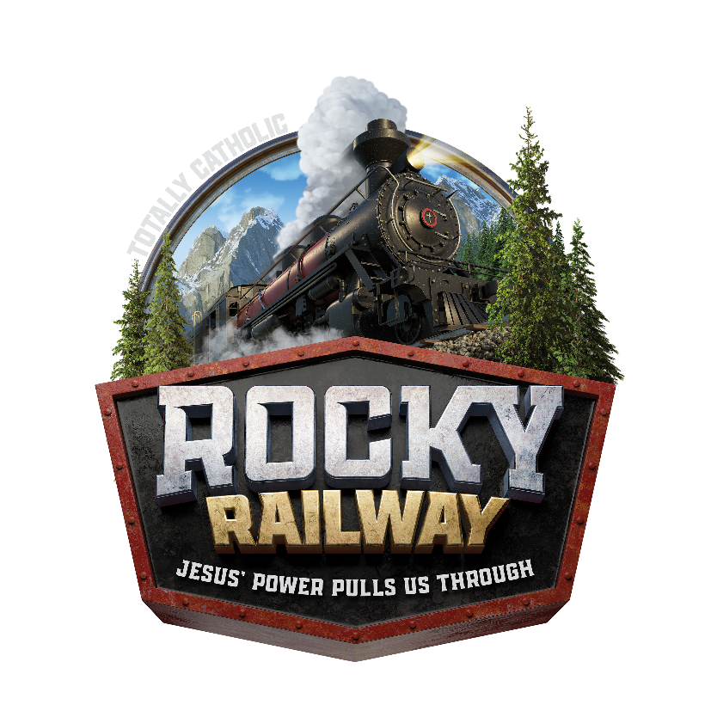

To purchase a CD or MP3 card of Rocky Railway songs click on one of the links below:
Rocky Railway Music CD:
https://www.concordiasupply.com/Sing-Play-Express-Music-Student-CD-Rocky-Railway-VBS-2020-by-Group?utm_term=4582627031504561&utm_campaign=PPC_Shopping_VBS_ISO_GroupEZ&utm_medium=cpc&msclkid=8a4536821c4112db043e68547995b737&utm_source=bing&utm_content=VBS+2020+ISO+Rocky+v1
Rocky Railway Music MP3:
https://www.concordiasupply.com/Sing-Play-Express-Music-Student-Download-Card-Rocky-Railway-VBS-2020-by-Group?utm_term=4582627031504561&utm_campaign=PPC_Shopping_VBS_ISO_GroupEZ&utm_medium=cpc&msclkid=dee9254c20241bf655e77b9a4640ab22&utm_source=bing&utm_content=VBS+2020+ISO+Rocky+v1

