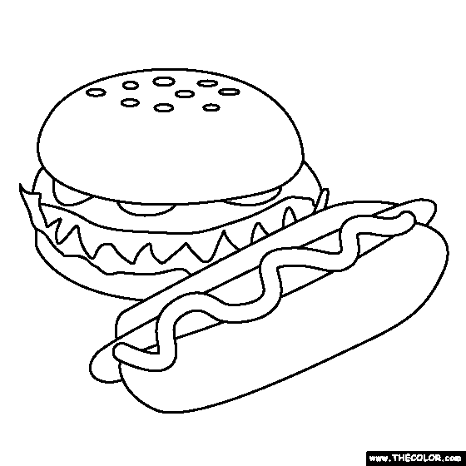
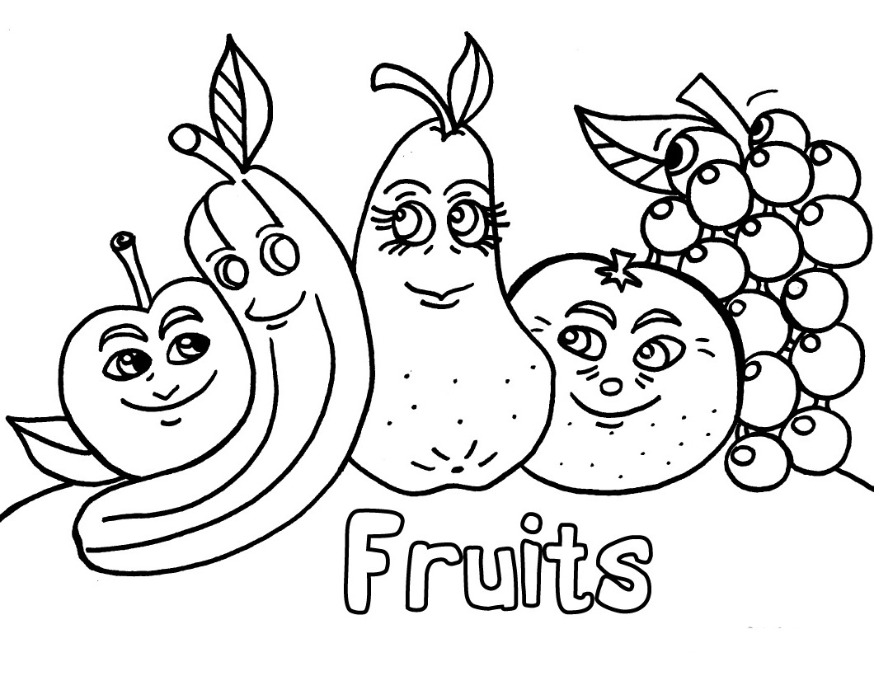
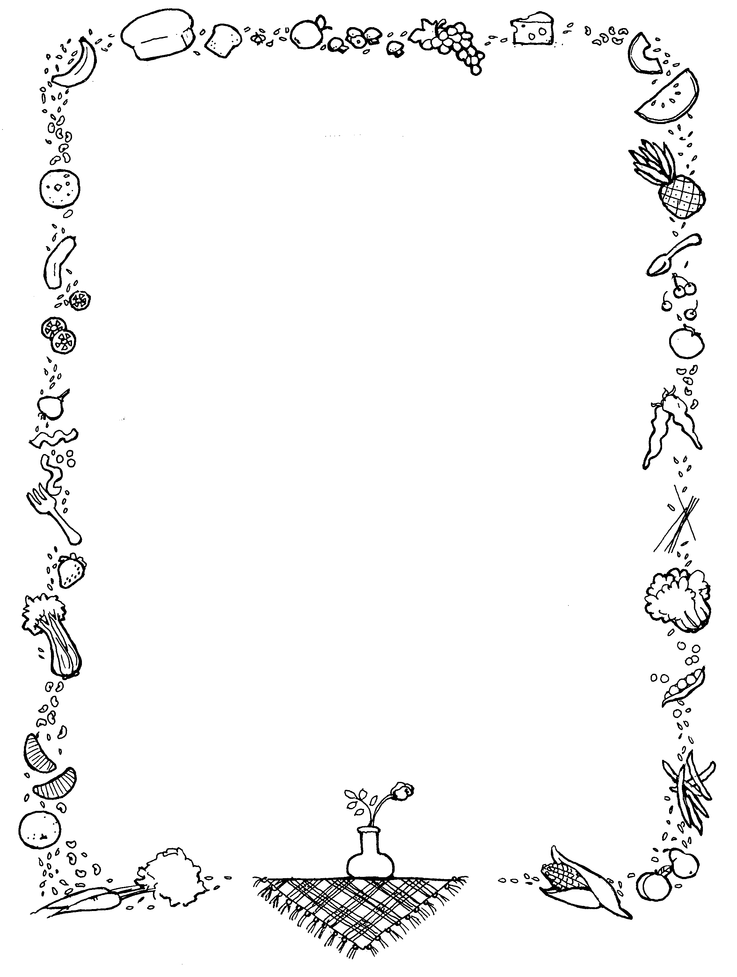
Menu
Dinner will be served every evening from
5:15pm to 5:40pm. Please try to have the kids here by 5:30pm so they have enough time to eat. Thanks!!!!

Monday- Chick Nuggets or Nacho’s

Tuesday- Corn Dogs or Hot Dogs

Wednesday- Taco Salad

Thursday- Hot Dogs or Burgers

Friday- Cheese Quesadillas and any leftovers we have

**Chips & Fresh Fruits served every night**
Lemonade, Tea, or Water for drinks

