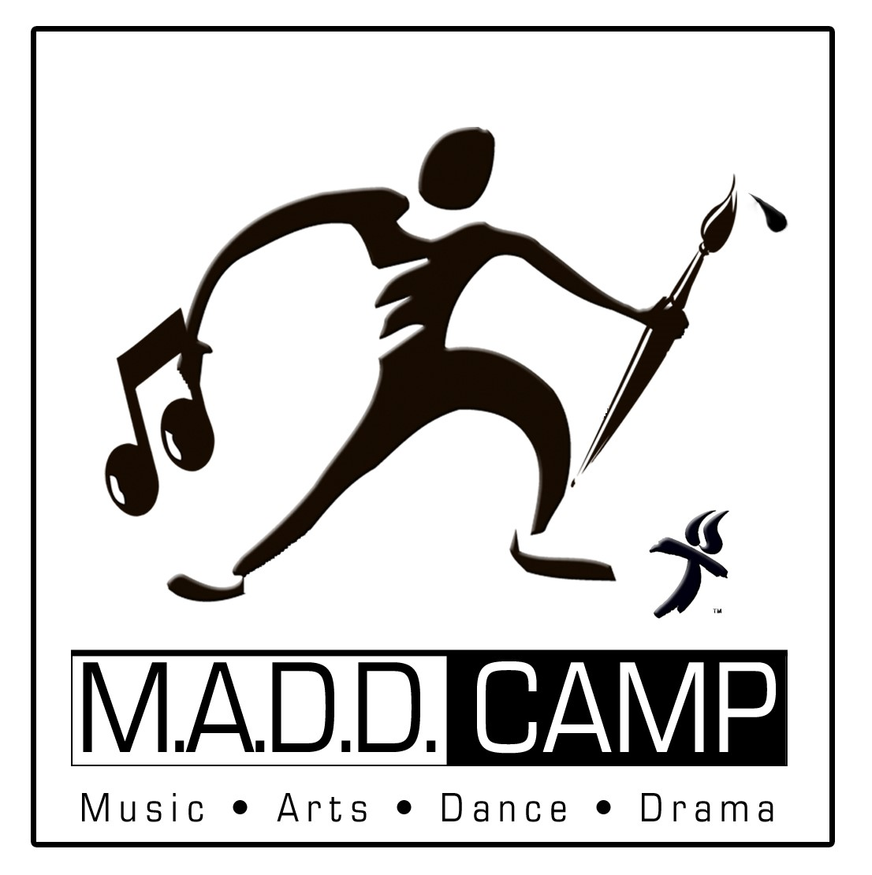
PARENTAL CONSENT FORM
Parent/Guardian Name_____________________________
Date___________
To whom it may concern:
The undersigned does hereby give permission for our/my child/ren, to attend and participate in International Gospel Center’s MADD Camp, July 25 - 29, 2022.
List Children’s Names Below:
_____________________________________________________________
PLEASE PRINT OFF & INITIAL BESIDE EACH STATEMENT BELOW, THEN SIGN & BRING WITH YOU ON THE FIRST NIGHT OF CAMP:
_______Before any medication is dispensed to my child, I will fill out a written Authorization for Medication located in the office. All OTC medication must be accompanied by a doctor’s note. Medicine must be in the original container with my child’s name Marked on it. All medication will be given to staff member only and not left with the child.
_____Should my child suffer an injury or illness while in the care of International Gospel Center's MADD Camp Staff and the staff is unable to contact me immediately, International Gospel Center shall be authorized to secure such medical attention and care for the child as may be necessary. I further agree to be fully responsible for all medical expenses incurred during the treatment of my child.
_____My child will not be allowed to enter or leave the IGC campus without being escorted by parent(s) or guardian, adult (over 18 years old authorized by parent(s).
_____I agree that images or video may be taken of my child and used by International Gospel Center's MADD Camp . No compensation will incur for any images or video used.
Signature _________________________________________Date______________________

