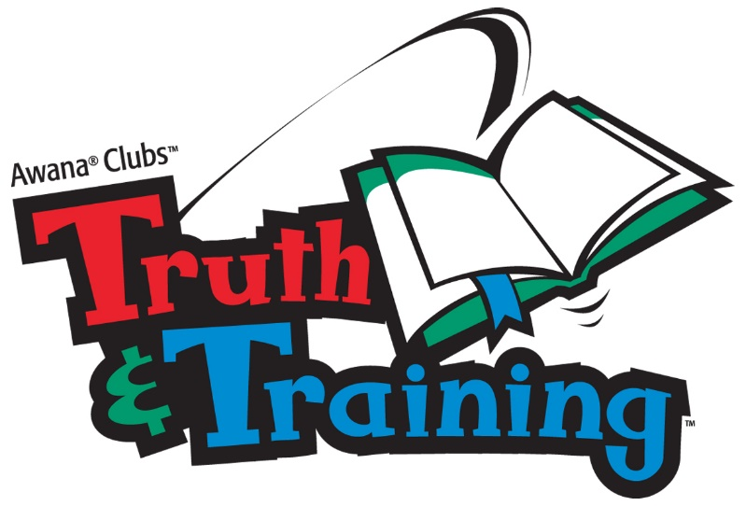 Ordered ______ Paid ______ Awarded ______

Clubber’s name ______________________________________

2018- 2019 Order Form

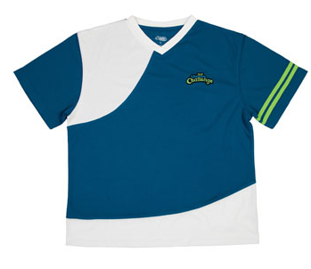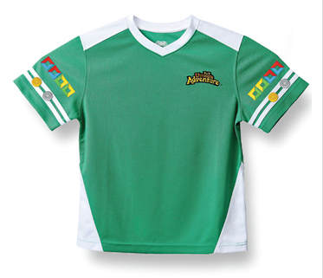 T&T Uniform Shirt $16.00 T&T Uniform Shirt……..$15.00

***(Green T, grade 3+4) (Blue and white, grade 5+6)***

YS, size 10 _____ YM, size 12 _____

YM, size 12 _____ YL, size 14 _____

YL, size 14 _____ Adult S _____

Adult S _____ Adult M _____

Adult M _____ Adult L _____

Adult L _____ Adult XL _____



Ultimate Adventure/

Ultimate Challenge Handbook…………… $10.00

Book _____________

Total ______________

*Please make all checks payable to Faith Discovery Church*