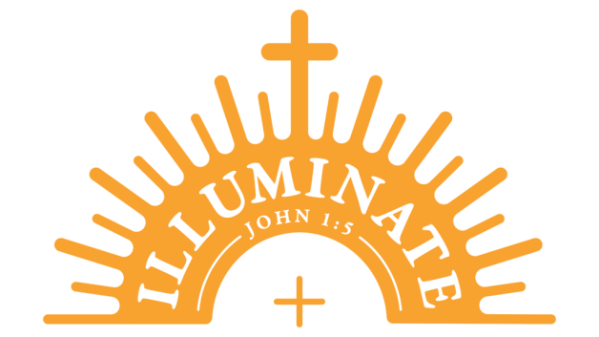

“The light shines in the darkness, and the darkness has not overcome it.” --John 1:5

**Steubenville Youth Conference - Lonestar**

**June 21-23, 2024**

Catholic conference to bring high schoolers into a

life-changing encounter with Jesus Christ!

* We will be traveling by passenger van or bus to Irving, TX.

* Hotel accommodations will be 4 people to a room with two queen beds.

* Roommate requests are taken into consideration,

but we cannot guarantee that we will honor your request.

* Chaperone requirements are 1 adult (over age 21) per 8 students of same gender.

* If any parent would like to come along as a chaperone, the cost is the same for adults. All adults must have a current blue card (Safe Environment for Children) and completed background check on file before attendance.

* Meals are included in the total attendance cost for Friday dinner,

Saturday breakfast/lunch/dinner, and Sunday breakfast.

* Friday lunch and Sunday lunch/dinner we will get something while traveling.

* Several fundraising opportunities will be offered. Only students who participate will be awarded funds from the fundraiser.

* Fundraising will consist of bake sales, car wash, a luncheon, etc.

* Cost breakdown: $80 hotel, $200 conference fee, transportation ?? (based off of total number of people attending). We are trying to make this as affordable as possible.

**Please do not let the cost deter you from attending. Take advantage of fundraising!!**

* Payment plan schedule:

Non-refundable deposit $75 due by March 10th to secure early bird registration. If registering after March 10, the conference fee increases by $15

Final balance due June 10th.

(Any fundraising participation will be deducted from final balance)

*Tentative schedule for travel:*

*Leave MPB around 8:00am on Friday, June 21st.*

*Arrive in Irving by 3:00pm and check-in to hotel.*

*Conference begins Friday evening.*

*Conference ends early afternoon on Sunday.*

*Leave Irving and arrive back at MPB around 8pm June 23rd.*

<https://lifeteen.com/events/steubenville-lone-star/>