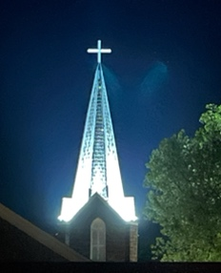**Minor’s Photo/Video Release Form**

Photographs and videos are a great way to promote and share the church events and activities. We especially like to include images of children participating in these events in various print and online media.

However, not everyone appreciates being photographed or filmed. We want to ensure that the privacy and wishes of all are respected. For this reason, we ask parents or guardians to complete this form and send it with their child(ren) to VBS.

I, ________________________________, am the parent or legal guardian of the following child or children under 18 years of age. I release and discharge the church from all claims, demands, and causes of action, which I have or may have by reason of this authorization. I have read this contract in its entirety, understand and agree to all of its terms.

___________________________________ ___________________________________

Child’s Name Child’s Name

___________________________________ ___________________________________

Child’s Name Child’s Name

___________________________________ ___________________________________

Child’s Name Child’s Name

Please indicate below if you grant or deny permission to First Presbyterian Church of Pataskala to use your child(ren’s) photographs or videos in any and all church publications both private and public for display, educational and/or promotional purposes.

_______ I DO give permission for my child(ren’s) photos/videos to be used.

_______ I do NOT give permission for my child(ren’s) photos/videos to be used.

Parent/Guardian Signature Date