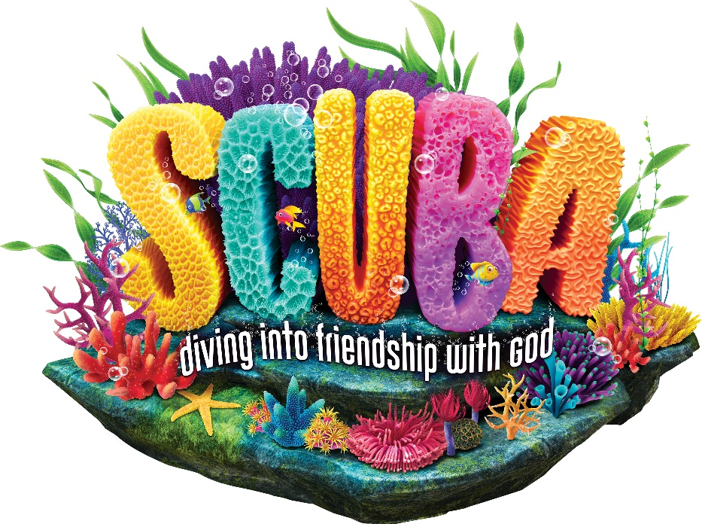

**Dayton**

**Community Church**

**Vacation Bible School**

**July 22nd – July 26th**

**5:15pm – 8:45pm**

**Program July 28th at 10:30am**