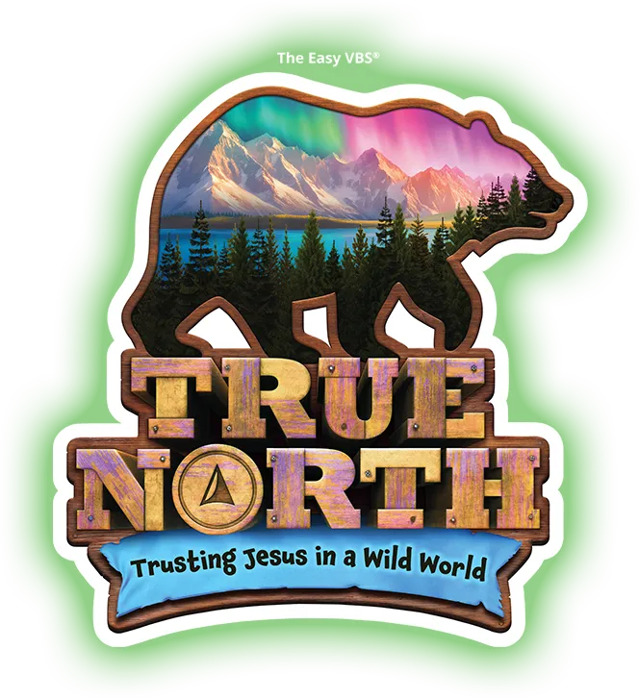

We’re headin’ north! TRUE NORTH!!!

I hope you have your coats, boots, hats, gloves, scarves…oh wait…nevermind! We don’t want anyone suffering from heat-stroke in the middle of summer in Georgia! What we do want is YOU to be there, thinking cool, AND staying cool! We are so excited that you are interested in joining us on our TRUE NORTH VBS adventure where we will be TRUSTING JESUS IN A WILD WORLD! (*What a relatable theme!!!*)

As a volunteer, here are some super important things to know:

* VBS is July 21-25, 9-Noon @ the Main Post Chapel. (For volunteers it starts at 8:15 on Monday, and 8:30 the rest of the week, and ends around 12:15ish. It depends on now how quickly kids are picked up/your area is ready to go for the next day)
* Anyone 12yo and up can volunteer!
* Everyone 13yo and up has to have a background check done. No, if ands or buts! We are here to help you get through the process as quickly and as easily as possible!
* Have kiddos too young for VBS? No worries! We have a Preschool VBS program for the 4 year olds (who are potty trained) and nursery for kiddos 6mo-4yo (not fully potty trained).
* Have a kiddo younger than 6mo, but still want to volunteer? A lot of our mamas baby wear and have a great time!
* Wondering how much prep work will be needed on your part? It depends on what you volunteer to do. Crew leaders and assistants have zero prep work, and maybe 5-10 minutes of “pew straightening” time at the end of each VBS day. Station leaders have some prep work, and the amount depends on the station. If you have questions about a particular position, just ask! We’re here to help!
* We literally have a position for everyone! Those that like to have fun with kids, those that like admin stuff, those that like to decorate, those that like being in the kitchen…if you aren’t sure which would fit you best, let us know, and we’ll help you find the best fit.
* Everyone gets a free VBS t-shirt (nursery kiddos excluded). Volunteers will have one color and participants will have another. Your VBS t-shirt is your uniform of the week. Want to dress it up? Our VBS adventure is taking us into the great Alaskan outdoors this year, so grab a walking stick, a fishing hat, a plaid vest, some cargo pants/shorts and come ready to hit the trail!
* Important Dates: July 19, 10-2pm or July 20, 1-3pm Stop in for a minute or two and get your t-shirt, meet some fellow adventurers, and if you like, stay to help decorate! There will also be a couple of Mandatory training meetings to choose from, but you only need to attend ONE! Optional Prep/Work Day dates will be sent out via e-mail and posted on the FB page. (Please be sure to check one or the other!)
* We are thrilled that you are joining us on this adventure in TRUSTING JESUS IN THIS WILD WORLD and can’t wait to see what He does in the lives of so many this VBS season! It’s going to be a true experience!
* Have more questions? E-mail mainpostchapelvbs@gmail.com

Your fellow VBS Adventurer,

Sarah Beaman

VBS Director