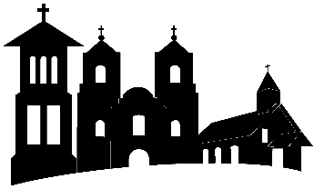
ST. PETER THE APOSTLE CATHOLIC CHURCH
202 W. Kronkosky St., Boerne, TX 78006
(830) 816-2233

MODEL RELEASE STATEMENT

I DO NOT give permission for my child/children named on this form to be photographed/or videotaped during VBS activities; and for the resulting photographs and/or videos footage to be broadcast for the finale of VBS and on all ST. Peters social media platforms and website.

Parent/Guardian signature_________________________________________

