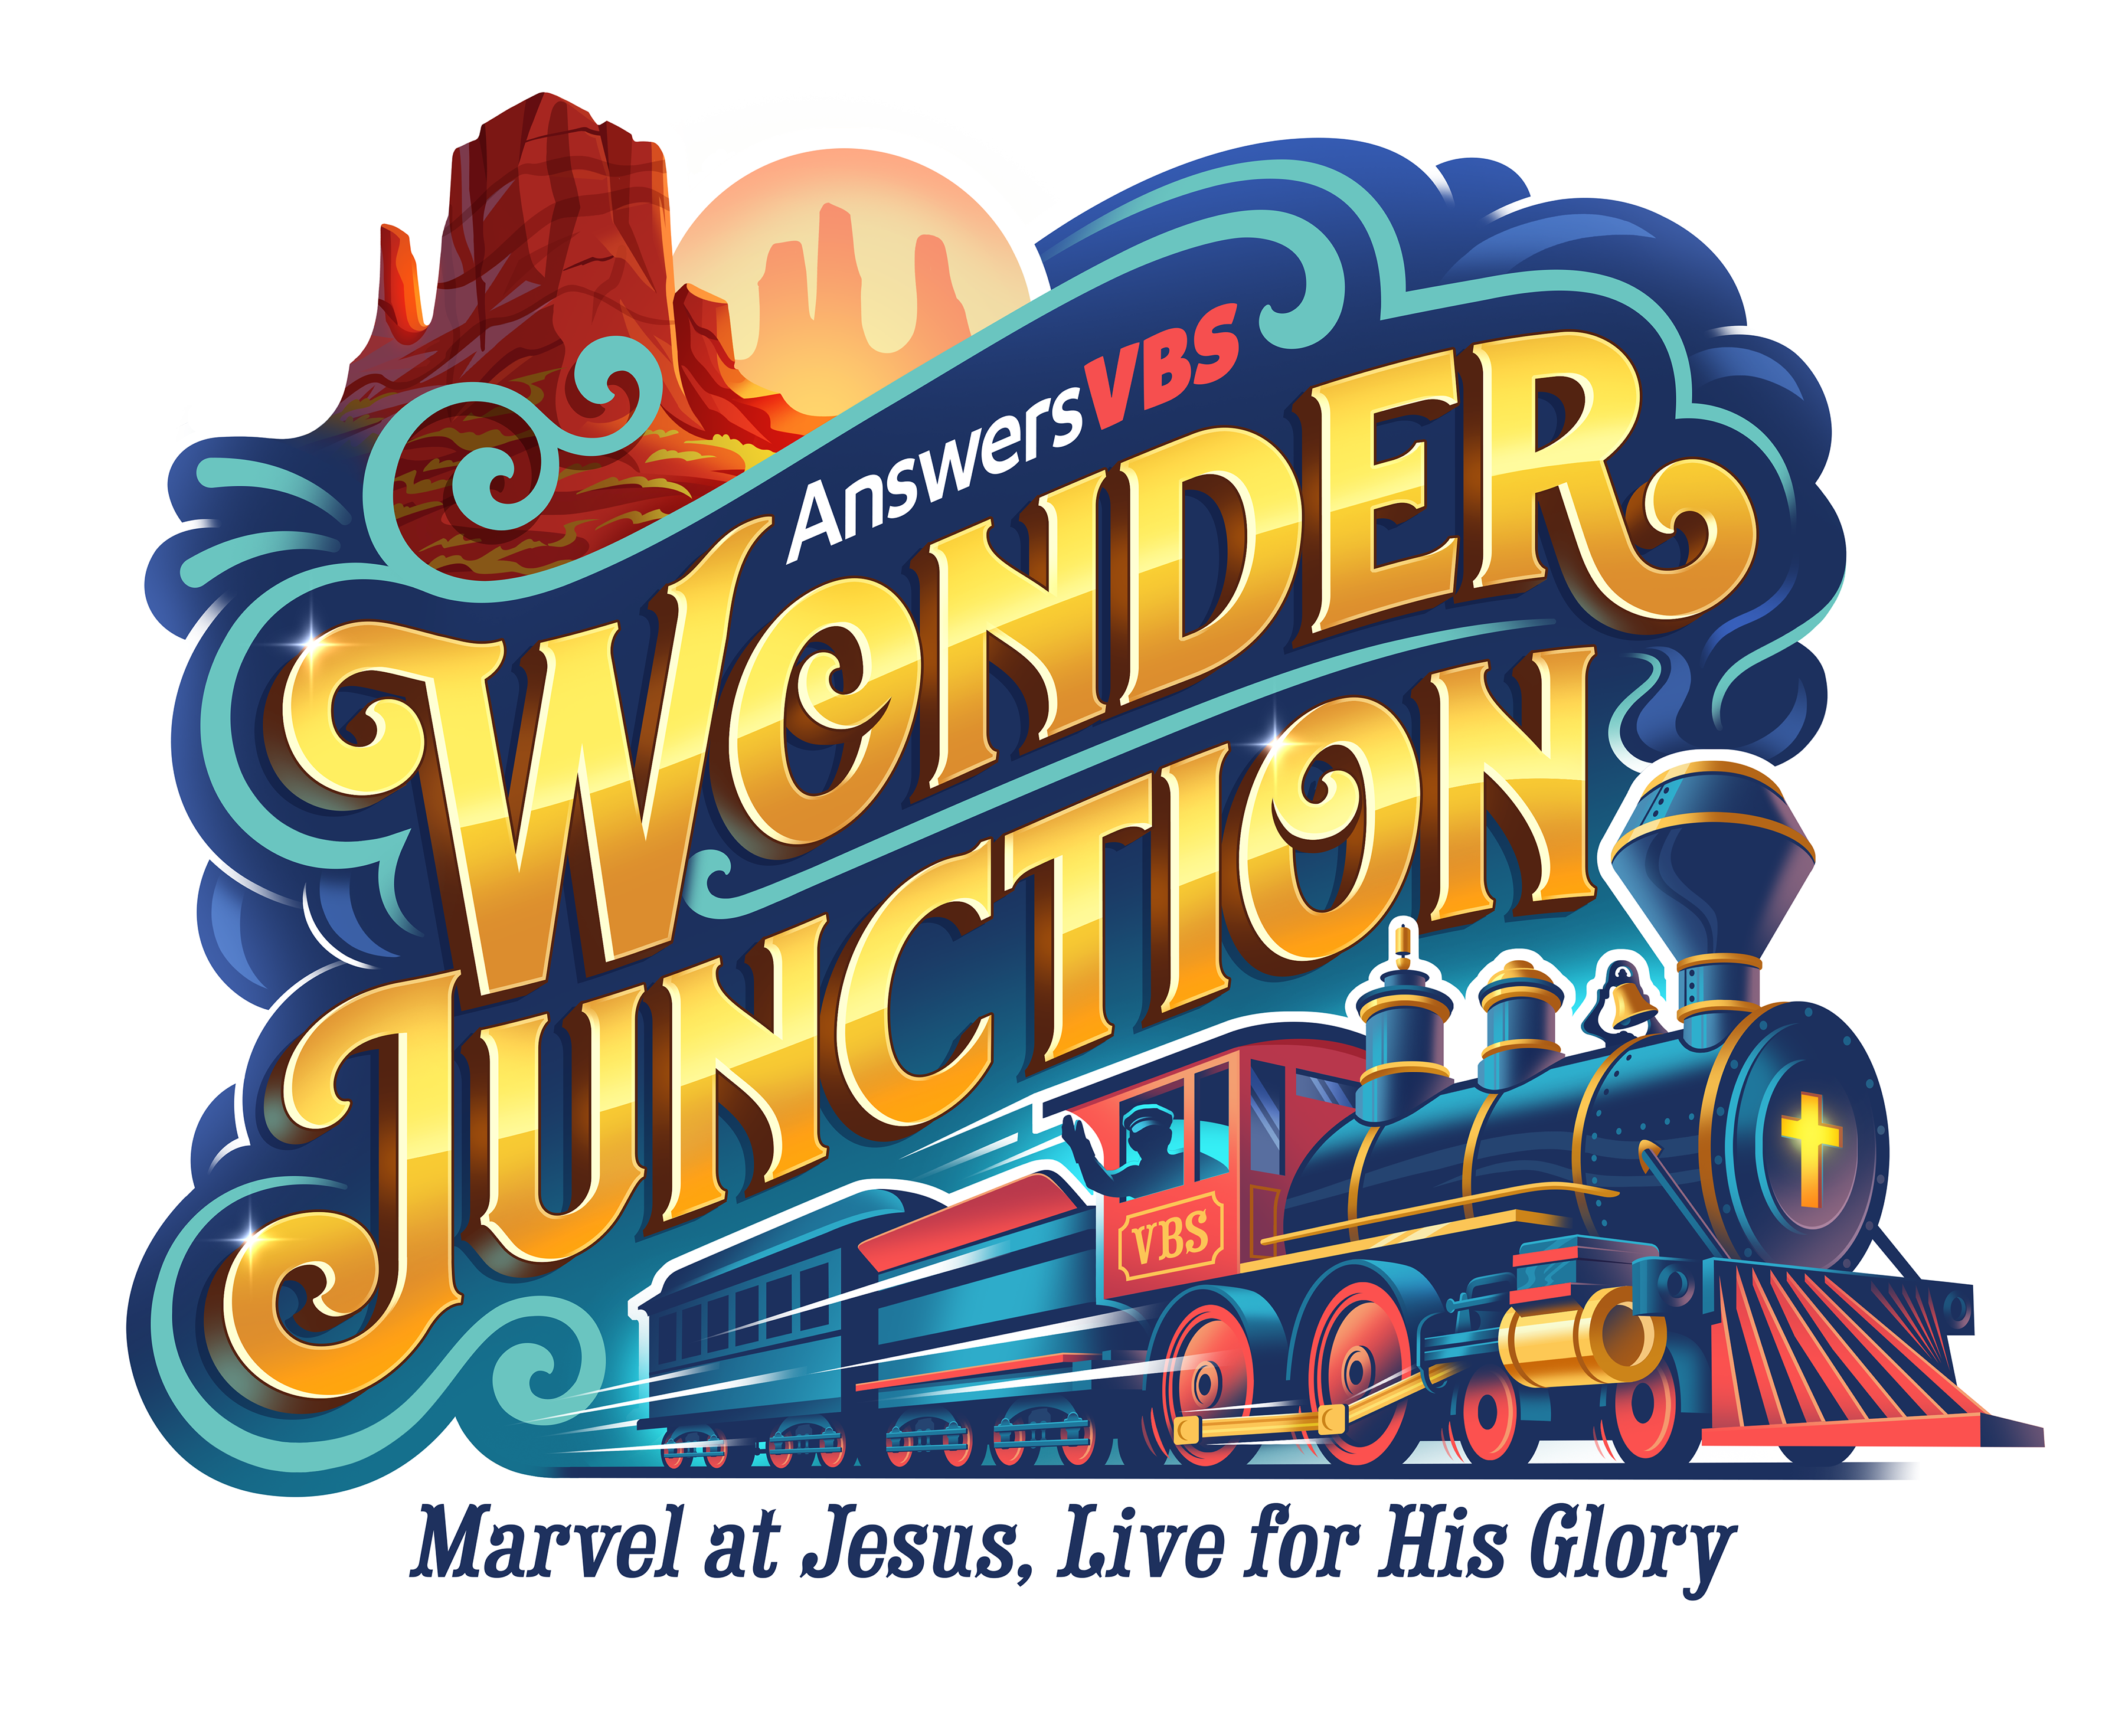

Student Assistant Application
FORM C

All youth under the age of 18 who have applied to be a station helper, preschool or elementary crew leader MUST complete the following application. Personal spiritual growth is a key element in the life of any ministry volunteer. Once complete, please return to the Church Office or the Children’s Welcome Center. THANK YOU for SERVING and REACHING IN WITH PURPOSE!

Personal Information:

Name: ___________________________________________________________________________
Last First Middle Initial
Address: _________________________________________________________________________

City: _______________________________________ State: _________________ Zip: ___________

Phone: (____) _____________________ Grade: _______________ Age: ____________________

Spiritual Life:

Give a brief account of how and when you became a Christian: ___________________________

_________________________________________________________________________________

_________________________________________________________________________________

_________________________________________________________________________________

If a 2nd grader asked you to explain God’s plan of salvation, what would you tell him or her?
_________________________________________________________________________________

_________________________________________________________________________________

_________________________________________________________________________________

Why do you want to help with VBS? _________________________________________________________________________________

_________________________________________________________________________________

_________________________________________________________________________________

FORM C

References:

Please obtain a written recommendation from two adults at Harvest who are not related to you.
(e.g., current, or former Sunday school teachers, Awana leaders, family friends, etc…)

I believe _________________ would make a good VBS Helper because:

_________________________________________________________________________________

_________________________________________________________________________________

_________________________________________________________________________________

_________________________________________________________________________________

_______________________________________ _____________________________________
Signature Please Print Name

I believe _________________ would make a good VBS Helper because:

_________________________________________________________________________________

_________________________________________________________________________________

_________________________________________________________________________________

_________________________________________________________________________________

______________________________ _______________________________
Signature Please Print Name

Applicant’s Statement:

I understand that serving in the role of VBS Helper will cause the younger children to see me as a role model. Because of that, I agree to do my best to behave in a Godly fashion at all times; both in church, and in my life outside of it. I will do my best to assist the teacher(s) in the classroom in a way that glorifies God, and helps the children grow in their understanding and love for Him.

_______________________________ _____________________
Student’s Signature Today’s Date

________________________________________
Office Use Only: Children’s Ministry Approval
________________________
Director Date
Parent/Guardian’s Signature

