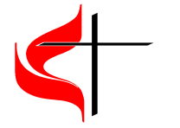Zachary United Methodist Church
Zachary, LA
2019 Rolling River Rampage Vacation Bible School
Medical Release and Permission to Photograph Form

Medical Release
I, ________________________ understand Zachary United Methodist Church will
Print Parent/Guardian Name
make every effort to contact me, or those named, in case of an emergency requiring a physician. However, if unable to make contact, the Church leaders are hereby authorized to take whatever action is deemed necessary in their judgement for the health of my child(children), _________________________________. I also Print Child’s/Children’s Name understand that the Church has no financial responsibility for emergency care for my child or transportation in an emergency vehicle should the need arise.
I hereby authorize and consent that Zachary United Methodist Church to take photo(photo’s) of my child (children) that may be used in its publications (newsletters, weekly emails, worship bulletins, slideshows, etc.) including website entries.

Parent/Guardian Signature
_____________________________________________

