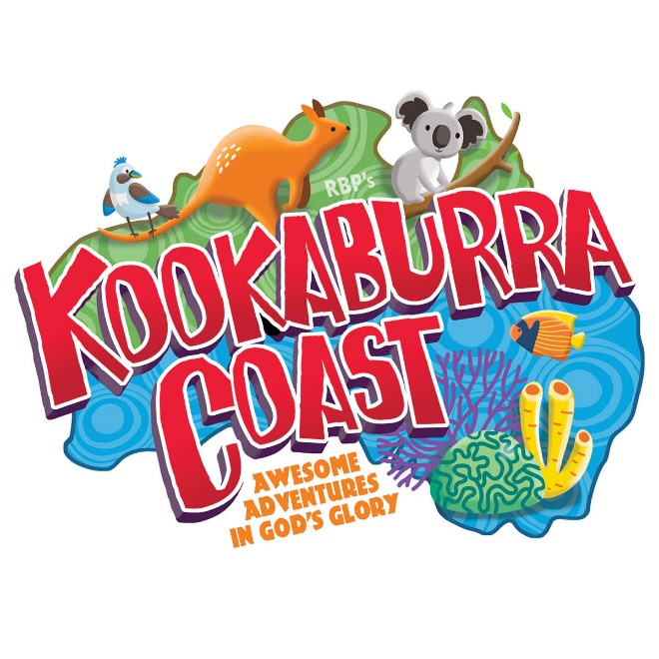
VBS Celebration Service
Saturday July 25th
11am-1pm
Come see children present songs and memory verse. See last puppet and actor skits.
Lunch provided afterwards with hotdogs, chips, cookies, refreshments, and sno cones!
20ft water slide and smaller water slide with jumper attachment set up in shade
Bring swimsuits and towels and join the fun!!!
Waterslides are reserved till 4pm so welcome to stay over

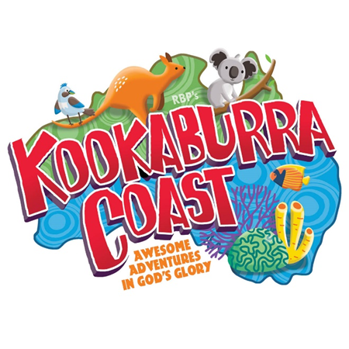
VBS Celebration Service
Saturday July 25th
11am-1pm
Come see children present songs and memory verse. See last puppet and actor skits.
Lunch provided afterwards with hotdogs, chips, cookies, refreshments, and sno cones!
20ft water slide and smaller water slide with jumper attachment set up in shade
Bring swimsuits and towels and join the fun!!!
Waterslides are reserved till 4pm so welcome to stay over

