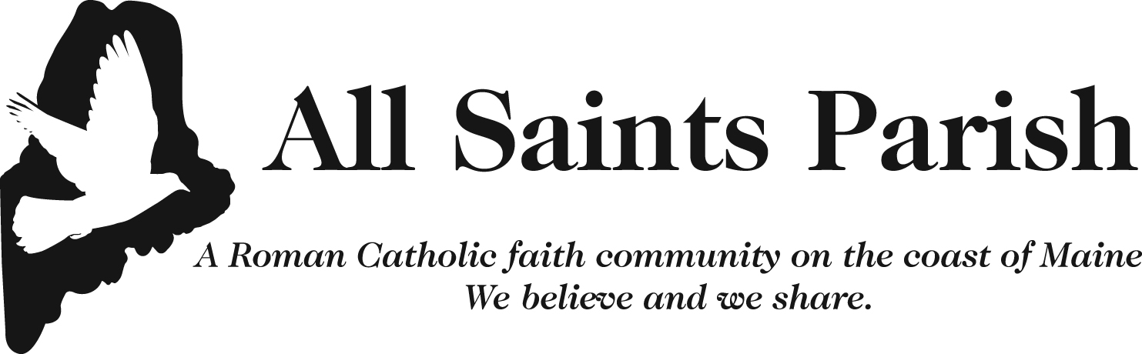

VBS IMAGE RELEASE FORM
There are times when we would like to share good things happening in the parish/school and diocese. To do this, we need parental permission to publish or publicly display photographs, videos, or other media that includes images of minors. This includes print and digital formats used by the parish/school or diocese such as bulletins, newsletters, websites, Facebook, or Instagram.
This form will authorize the Roman Catholic Diocese of Portland in Maine and the parish listed above to publish the following:
- Photographs, videos and/or audio recordings of participants, including minors, at or involved in school, parish and/or diocesan activities.
- First name of participants and/or minors, grade level, activity and/or brief description related to image, video or audio recording.
- Individual or group work from school, parish or the diocese, such as creative writing, research projects, artwork, music, performances, and audiovisual presentations.

Please list the names of all your children who may be involved in parish or diocesan activities. Indicate your permission by circling “Yes” or “No” for each child.
Name of Child/Adult (list below) | I give my permission to display or publish my child’s image as described above.
 | YES NO
 | YES NO
 | YES NO
 | YES NO
 | YES NO

Legal Guardian Signature: _____________________________________ Date: _________________
Legal Guardian Name (print): ___________________________________

