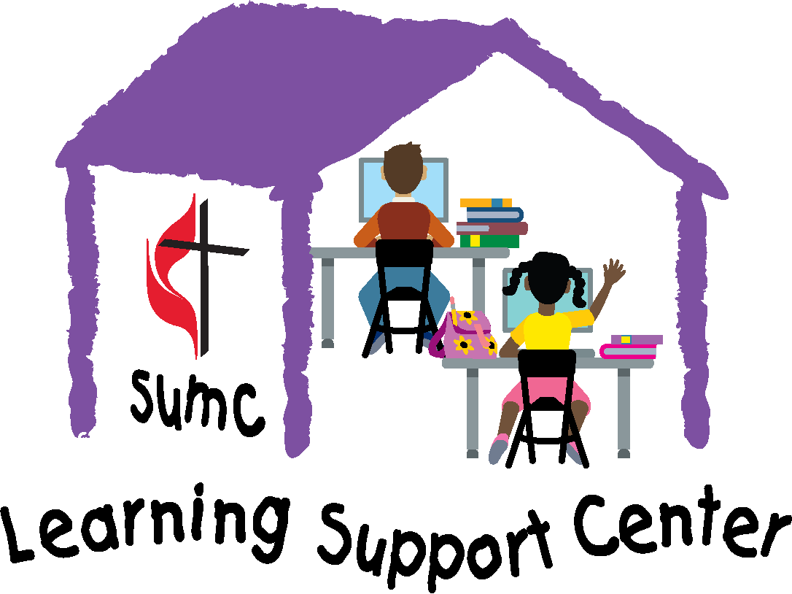
Stewartstown United Methodist Church
Learning Support Center
SCHOLARSHIP APPLICATION FORM
Stewartstown United Methodist Church desires that all children and youth be able to attend its Learning Support Center, regardless of their ability to pay. Through generous donors, funds exist to assist families who do not have sufficient income, or other forms of community financial support, to cover the full tuition. Individual students are limited to one scholarship per semester.
- We ask the student and their family to complete this form together. By completing this form in its entirety, you are certifying that there is financial need greater than can be provided by your family and your community of support.
- Families or individuals are asked to provide a portion (whatever is possible) of the cost. In this way the scholarship fund can help more students, and you can share in the joy of making the learning experience possible, too. Please check with other sources of support, like extended family and faith families, so our limited scholarship funds can help as many children as possible.
- Please send the completed scholarship application to: Stewartstown UMC Learning Support Center 26 South Main Street, Stewartstown, PA 17363
Scholarship Application (one student per form)
Student’s Name: ________________________________________________
Parent/Caregiver’s Name: _________________________________________
Mailing Address: ________________________________________________
_________________________________________________
Grade ______________________ Age: _____________________________
Signature: _________________________________________
Phone Number: _____________________________________
Email Address: ______________________________________
In a few sentences, tell us why the Learning Support Center is important for you; our donors appreciate hearing how they’ve helped a young person succeed in school.
____________________________________________________________________________________
____________________________________________________________________________________
____________________________________________________________________________________
To make it possible to provide support for as many children as possible, we ask that your family contribute what you are able to.

Your Plan for Covering the Cost of the Learning Support Center
Total Tuition per week ($25 times the number of days per week): $____________
Family Contribution per week: $____________
Other Support: $____________ Name of Other Support: ____________________________________
Request from Scholarship Fund per week: $____________

Please contact us if you have questions or if we can be supportive in other ways: LearningSupport@StewartstownUMC.org or 717-993-2507.

Office Use Only
Date Received: ___________ Scholarship Amount Granted: _______________
Confirmation Sent to Applicant: _______________ Approved By: ____________________________
(date)

