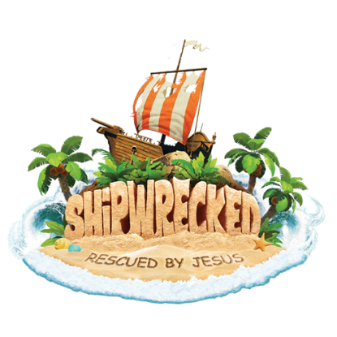
STATEMENT OF RELEASE
My child, _________________________ has permission to participate in all VBS activities and to use play equipment under supervision except for limitations noted. I agree that Second Presbyterian Church, and staff will not be held responsible for accidents or injuries arising from participation in the program. I grant permission for the camp personnel to provide routine health care and to seek emergency medical care if warranted. I grant permission for my child to be included in documentation of activities or programs through use of videos, photos, or printed materials, which may include crew photos, area newspaper articles, Second Presbyterian Church. In consideration of my child’s opportunity to participate in the program, I agree to release and hold harmless, Second Presbyterian Church, its agents, representatives, and employees from all claims, damages, or liabilities concerning my child which are not the result of gross or intentional negligence or willful or wanton conduct by the camp, it’s agents, representatives or employees.

Parent/Guardian Signature Date

