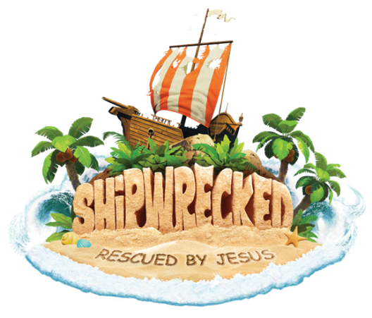 Shipwrecked VBS

July 8-12, 2018

Glenview Alliance Church

10037 Susquehanna Trail S., Glen Rock, PA 17327

[www.glenviewcma.org](http://www.glenviewcma.org) (717)-428-2502

Medical & Photo Release

* By checking this box, I, the undersigned Parent or guardian of ________________________________, do hereby authorize adult volunteers of Glenview Alliance Church as agent(s) for the undersigned, to consent to any medical or surgical care deemed advisable by any accredited physician or surgeon in an approved emergency clinic or hospital. I further release from any liability any of its ministries or leaders in the event of an accident in route during and returning from the above mentioned event. This agreement does not apply for intentional misconduct or gross negligence.
* By checking this box, I give my permission to allow my child’s image to be recorded by photograph or video and used during the VBS week or for future advertisement for Glenview’s children’s ministry events.

Parent signature _________________________________________________ Date _____________________