

2026 OSLC VBS Mission
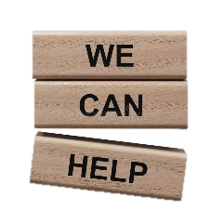
A group of youth and adults from OSLC are going to Detroit to help build, restore, and clean-up impoverished neighborhoods.
OSLC offers VBS for FREE, but encourages every student attending to participate in this mission effort.
We will be collecting the following supplies:
Day 1- fruit snacks or granola bars
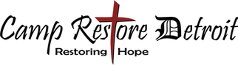
Day 2- peanut butter or grape jelly
Day 3- Ziploc bags or trash bags
Day 4- pens or pencils
Day 5- crayons or markers
ABOVE & Beyond= NEW puzzles or games (for kids)
**Most of these items can be purchased at a dollar store. Thank you for your support and generosity.

Join the Fun!
Be a part of the excitement by participating in the following daily themes:
Sun- Favorite Team
Mon- green or brown (like a tree)
Tue- Superhero or Princess
Wed- wacky hair day
Thur- red, white & blue day Go USA!

