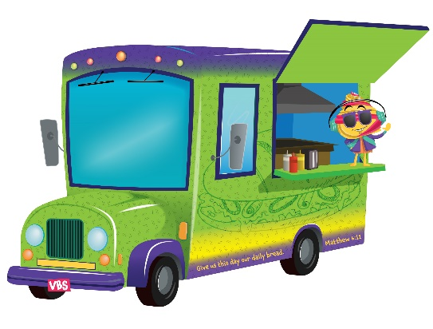
VBS Daily Details

Monday
Daily Special: God is Great!
Bible Story: God Provides Manna and Quail (Exodus 16)
Color of the Day: Blue
Snack: Graham Crackers*, Banana, & Honey

Tuesday
Daily Special: God is Good!
Bible Story: Elijah, the Widow and the Endless Oil (1 Kings 17:8-16)
Color of the Day: Purple
Snack: Bread*, Oil, & Dips

Wednesday
Daily Special: Let Us Thank God for Our Food!
Bible Story: Daniel and Friends Eating the Good Stuff (Daniel 1)
Color of the Day: Green
Snack: Fruit & Veggie Critters with Cream Cheese

Thursday
Daily Special: By God’s Hands We All Are Fed!
Bible Story: Jesus Feeds the 5,000 Plus (John 6: 1-13)
Color of the Day: Orange
Snack: Goldfish* Snack Mix (Goldfish, Chex, Raisins, Chocolate Chips, etc.)

Friday
Daily Special: Give Us, Lord Our Daily Bread!
Bible Story: Jesus Cooks the Catch of the Day (John 21:1-17)
Color of the Day: Pink/Red
Snack: Popsicles

Sunday
Daily Special: “Give us this day our daily bread.” Matthew 6:11
Color of the Day: VBS T-Shirt
Snack: Donuts!

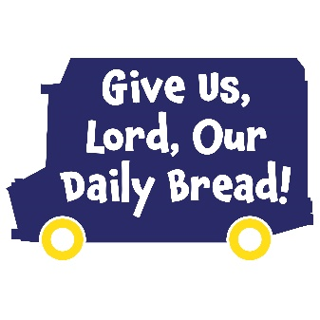
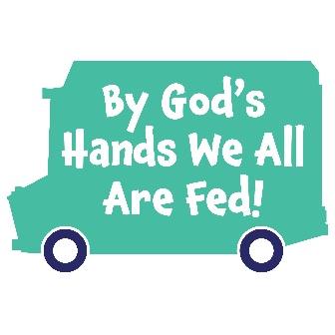
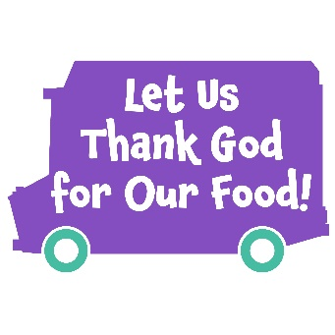
*Gluten Free Options Available – All Snacks are Nut Free

