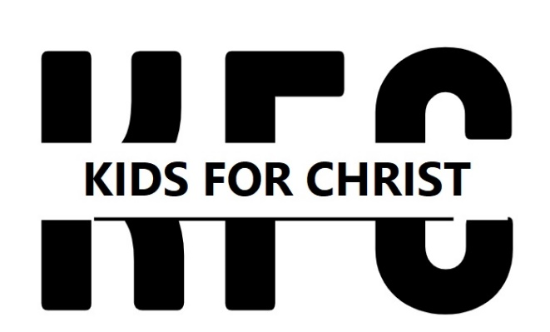

2022-2023 Calendar
Thursdays 5:00-6:30
5:00-5:30 Dinner
5:30-5:45 Opening Devotion
5:45-6:30 Class

Thurs. Sept. 8 First Day of Class
Thurs. May 18 Last Day of Class

NO CLASS DAYS:

Thurs. Nov. 24 Thanksgiving Break
Thurs. Dec. 15, 22, 29 Christmas Break
Thurs. March 23 Spring Break
Thurs. April 6 Maundy Thursday

