Prepare for Battle… Families fight together.
Day One: Introduction and the Belt of Truth

Thank you for participating with your child in Bible Boot Camp this week! Unity is vital to warfare. Ephesians 4:1-3 calls us to be united in everything we do:
I therefore, a prisoner for the Lord, urge you to walk in a manner worthy of the calling to which you have been called, with all humility and gentleness, with patience, bearing with one another in love, eager to maintain the unity of the Spirit through the bond of peace.
We appreciate the effort you put in to growing closer to our Lord Jesus Christ. This example shines for your child. Please enjoy doing this small study with your family each night to help reinforce the lessons your child learns each day. Be sure to read what’s coming next and prepare accordingly.
Today we introduced the Armor of God, as found in Ephesians 6:11-18. Your child is expected to have Ephesians 6:11 memorized by the end of the week. Feel free to memorize it along with them:
“Put on the whole armor of God, that you may be able to stand against the schemes of the devil.”
We had fruit roll ups as a snack and played a game called “Leaps and Bounds.” We also made cloth tool belts and worked on our activity books.
As a family, discuss the following questions and read the following verses:
- Read Ephesians 6:11-18
- Why is it important to know and “wear” the armor of God?
- Name all six pieces of armor.
- What is truth?
- How do the world and Christians view truth differently?
- What do tool belts do?
- Why is truth represented as a Roman soldier’s belt?
- How can you as a family practice putting on the Belt of Truth?
- Pray as a family.
Tomorrow send your child with a swim suit under their clothes so they can participate in the physical training activity. It would also be helpful if you sent a towel with them too. We will be discussing the Breastplate of Righteousness. Snack will be heart shaped sugar cookies. If you can, please send nonperishable food items with your child for our service project.

The Battle Continues… Families fight together.
Day Two: The Breastplate of Righteousness.

Righteousness is Christian lingo that often makes non-Christians feel excluded and uncomfortable. All righteousness really means is being RIGHT with GOD. Psalm 119:9-11 gives us an idea on how we can do that:
How can a young man keep his way pure? By guarding it according your word. With my whole heart I seek you; let me not wander from your commandments! I have stored up your word in my heart, that I might not sin against you.
As a family, discuss this passage of Scripture and what it has to do with righteousness. Here are some guiding questions:
- What is righteousness?
- What do we do to stay in a right standing with God?
- What does a breastplate protect?
- Why would a breastplate be used to represent righteousness?
- What are you going to do as a family to continue to strive for righteousness?
- Work on memorizing Ephesians 6:11
- Pray as a family.
Today we had a water balloon fight for our physical activity. This was to teach the young soldiers that it is important to protect your heart from being hit, because in this spiritual war we’re in, Satan likes to aim for the heart. Righteousness protects our heart and helps us stay pure from sin. We also made t-shirts to represent breastplates and ate heart shaped sugar cookies to remind us to protect our hearts from sin.
Tomorrow we will discuss the preparation that comes with the shoes of the Gospel of peace. Our snack will be pretzels, because they look like knotted up shoelaces. Be sure your child is in tennis shoes for tomorrow’s game! If you can, please send nonperishable food items with your child for our service project.

Thank you again for building a strong family in the name of the Lord!

The Battle Continues… Families fight together.
Day Three: Readiness and the Shoes of the Gospel of Peace

This is a pretty big topic to cover in one day! In a nutshell, today was all about evangelism. Gospel means good news. The good news is that Jesus came and lived a perfect life, then he was murdered for our wrongdoing. Three days later, he came back to life and ascended into Heaven. Because of these events, we can have eternal life in Heaven. This should fill us with an abounding sense of peace.
Together, read John 16:33 and 1 Peter 3:15. Discuss the following questions as a family.
John 16:33
I have said these things to you, that in me you may have peace. In the world you will have tribulation. But take heart; I have overcome the world.
1 Peter 3:15
But in your hearts honor Christ the Lord as holy, always being prepared to make a defense to anyone who asks you for a reason for the hope that is in you; yet do it with gentleness and respect.
- What is the Gospel, and why does it bring us peace?
- Why does preparation go on our feet?
- What are we called to be prepared for?
- How will your family prepare to share the Gospel with others?
- Work on memorizing Ephesians 6:11
- Pray as a family.
Today we did a physical activity in which we all put a shoe in a pile, then we found someone else’s shoe and helped them put it on while we asked them questions about themselves. This game helped us learn service and putting others first. We had pretzels for a snack and decorated shoelaces.
Tomorrow we will discuss the Shield of Faith. Our snack will be Rice Krispy treats because they resemble shields. Make sure your child is wearing clothes that you don’t mind being ruined we will be painting tomorrow. If you can, please send nonperishable food items with your child for our service project.

The Battle Continues… Families fight together.
Day Four: The Shield of Faith
By now, I’m sure your little soldier is getting tired from a long and challenging week. Don’t worry, there’s only one more day to go. Thank you for your ongoing commitment to Bible Boot Camp. Today we discussed the Shield of Faith and its ability to move and cover weaknesses we have in our lives. Nehemiah 9:30-33 gives a different view of righteousness:
Many years you bore with them and warned them by your Spirit through your prophets. Yet they would not give ear. Therefore you gave them into the hand of the peoples of the lands. Nevertheless, in your great mercies you did not make an end of them or forsake them, for you are a gracious and merciful God.
Now, therefore, our God, the great, the mighty, and the awesome God, who keeps covenant and steadfast love, let not all the hardship seem little to you that has come upon us, upon our kings, our princes, our priests, our prophets, our fathers, and all your people, since the time of the kings of Assyria until this day. Yet you have been righteous in all that has come upon us, for you have dealt faithfully and we have acted wickedly.
- What is the common understanding of faith?
- How does these verses show a different side to faith?
- What makes the shield different from the other pieces of armor?
- Why would faith be represented by a shield?
- What are some fears and doubts you and your family face?
- How can the Shield of Faith help you overcome that?
Today our physical activity was a form of dodge ball. The children used shields to protect themselves as we through balls at them. The point was to show how a shield moves to protect weaknesses. We had Rice Krispy squares as a snack and decorated poster board shields.
Tomorrow we will cover a lot of ground so make sure your child gets a good night’s sleep. We will discuss the Helmet of Salvation and the Sword of the Spirit. The snack will be trail mix, so please let our staff know if your child has nut allergies so we can make accommodations. If you can, please send nonperishable food items with your child for our service project.

The Battle Continues… Families fight together.
Day Five: Helmet of Salvation and the Sword of the Spirit

You made it! The last day of Bible Boot Camp has come to a close. Thank you for the support you have provided for your child this week. Please enjoy this final family worksheet and please practice “putting on the armor of God” every day.
- Discuss the nature of salvation with your family. Belief in Jesus Christ and commitment to Him is vital to a happy, healthy family. Pray for your family and their salvation.
- Ask your child to go through all the pieces of armor that they made and explain what they represent.
- Why is salvation a helmet? Can this helmet ever come off?
- Why is the Word of God called a sword?
- Take time everyday to pray and read the Bible with your children.

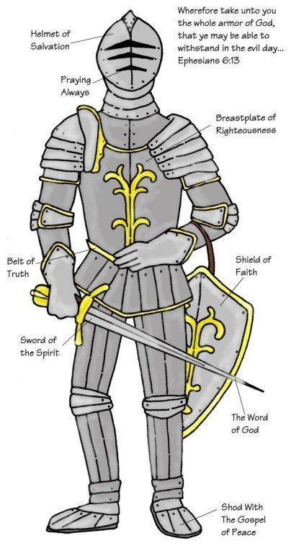
"Put on the full
armor of God,
so that you
will be able to
stand firm against
the schemes of
the devil."

~Ephesians 6:11

Congratulations on finishing Bible Boot Camp!

