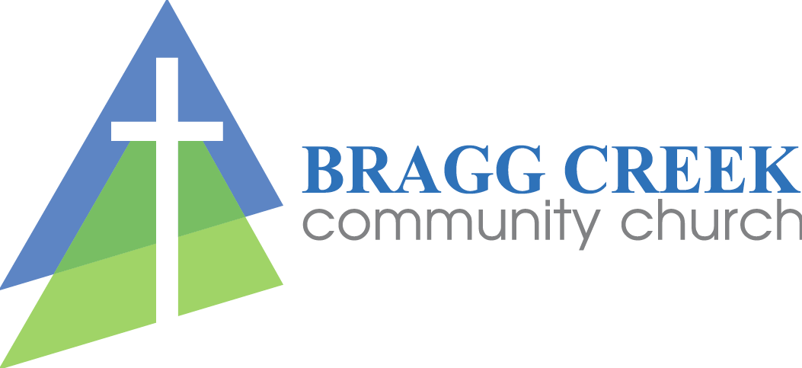

**Waiver:**

I/We, the parents or guardians of____________­­­­­____________(child’s name) authorize Bragg Creek Community Church staff to sign consent for emergency medical treatment and to authorize any physician or hospital to provide emergency medical assessment, treatment or procedures for the participant named above.

I/we, named above, agree to indemnify and hold blameless Bragg Creek Community Church, its staff and representatives from and against any loss, damage or injury suffered by the participant as a result of being part of the activities of the Bragg Creek Community Church, as well as any medical treatment authorized by the supervising individuals, representing the church. This consent and authorization is effective only on **July 3, 2025** when the above child is participating in Kids Camp at Bragg Creek Community Church.

Parent/Guardian Signature ____________________________________________

Printed Name____________________________________Date_________, 2025

**Photo Release:**

I/we named below grant permission for the reasonable use of pictures containing my child in any or all of the following, promotional material, website/social media, newsletter while participating at **Kids Camp on July 3, 2025**

Parent/Guardian Signature ____________________________________________

Printed Name____________________________________Date__________, 2025

___ I don’t grant photo permission